Kim Hancock

GOV

Election Assessment Memo

“Battle of the Steves”

Montana is a state that is solidly red across nearly all elected officials. The only exception is Democrat John Tester, re-elected to the Senate in 2018. Following the surprising 2018 wave of increased Democratic support in Montana, the 2020 senate race between incumbent Steve Daines (R) and term-limited governor Steve Bullock emerged as a tight race that would have been critical in Democrats taking majority control of the house. Despite being Montana’s most expensive senate race by over 200%, this “Battle of the Steves” ended up being an easy victory for Daines, who won by 10 percentage points. While Democrats lost various important Senate races, the fundraising records and increased voter turnout do show that grassroots fundraising and partisan engagement are on the up and up across the nation.

The Montana Senate primary was overwhelmingly predictable, with Daines winning 88.02% of the votes among running mates John Driscoll and Daniel Larson. Bullock landed 95.45% of votes among running mate John Mues (Ballotpedia). After a long-shot attempt in the presidential primary, Bullock was pretty upfront about how he did not want to challenge incumbent Daines for his Senate seat (Martin). However, union officials including senate minority leader Chuck Schumer reached out to Bullock. They wanted him to challenge Daines, believing he would be the most competitive candidate and offering to give him all the resources needed for an effective campaign. They were not wrong. It quickly became clear that Bullock was indeed going to (literally) give Daines a run for his money.

It also became clear that money was not going to be Bullock’s biggest issue. Daines himself raised $27,017,875 and spent $26,125,842, with his most recent cash on hand being $1,751,154. Bullock dominated these numbers, raising $42,773,128 and spending $38,694,940. His most recent cash on hand was $4,078,188 (Center for Responsive Politics). Interestingly, but perhaps unsurprisingly, most of the candidates’ individual contributions came from out of state. According to Montana Free Press, only 7.4% of Bullock’s individual contributions through October 14 were from Montana citizens, and 18.1% of Daines’ (Dietrich).

In terms of outside spending, Bullock received over $55 million, and Daines over $53 million. The Center for Representative Politics lists Montana as the fourth most expensive Senate race in the country in terms of outside spending, coming to about $232 per citizen; this is the highest per capita of any Senate race in the country (Rau). But while direct campaign contributions are easy to track, third-party money is more elusive. Since 501(c)(4) groups, or super PACs, aren’t required to disclose their donors (although some do), many of these unlimited contributions go undocumented. Both candidates have accused the other of accepting dark money contributions from big corporations (Ackley).

We see from Figure 1 that Daines received most of his PAC donations from the business sector, while Bullock received almost none. While this chart does not include Super PAC data, it still provides evidence that Daines was receiving more donations from corporations, at least on the surface. It is also interesting to look at outside spending data. The super PACs that contributed the most were the Senate Leadership Fund at $24,672,963 and the Senate Majority PAC at $16,599,421. The SLF spent all of this money in the MT senate race against Bullock, while the Senate Majority PAC spent all but $8500 against Daines (Center for Representative Politics). The donors to both of these groups were dominated by financial groups and investment banks, such as Pritzker Group and Blackstone (Center for Representative Politics). At the same time, many of the ads run for the race were attack ads funded by outside spending.

In terms of advertising, almost all of the ads launched for the Montana senate race were attack ads. The biggest issues that I read about and saw in ads were coronavirus response, healthcare, protecting the outdoors, and Daines’ involvement with business in China (Rau, Brown, Martin). Short and to the point, t[his advertisement](https://www.facebook.com/ads/library/?id=1610425279137951) is an attack ad by Bullock’s campaign about Daines setting up factories in China at the expense of people’s jobs in the US. It was one of the highest ads when sorted by impressions in the Facebook ad library. Other ads were even more harsh; [this ad](https://fb.watch/27-Eph_LZd/) has the slogan “Daines chose drug companies, not us” after he supposedly gave millions of dollars in tax breaks to big pharma. Made by a nonprofit group affiliated with the Senate Majority PAC, the ad is not supposed to endorse a particular candidate. In addition to being clearly partisan, the ad was misleading as it was referring to how Daines voted for a Republican-backed tax law enacted by Trump which reduced taxes on overseas profits (Kim). Finally, [this ad](https://www.facebook.com/ads/library/?id=1489315087946381) stood out to me for it’s shaky camerawork by Don Jr. He is asking for last minute donations to prevent Democrats from packing the supreme court and “letting the liberal mob win.” All three ads had over a million views, with the first two being aired primarily in MT while the last was aired mostly out of state (which makes sense since it was about donations).

The polls for this race consistently showed Daines at a slight advantage over Bullock, with one or two showing Bullock slightly ahead. A true toss-up in the polls leaves me wondering why Daines’ 10-point win was not predicted. [Public Policy Polling](https://www.publicpolicypolling.com/wp-content/uploads/2020/10/MontanaOctober2020Poll.pdf) showed both candidates at 48%; [Treasure State 2020](https://helpslab.montana.edu/documents/treasure_state_2020_election_surveys/Senate_Overview_Final_11Oct2020.pdf) by Bozeman University and [NBC Montana](https://nbcmontana.com/news/beyond-the-podium/nbc-montanastrategies-360-poll-shows-extremely-tight-montana-races) showed Bullock at 49% and Daines at 47%; finally, [NYT/Sienna College Research Institute](https://int.nyt.com/data/documenttools/mt101820-crosstabs/1bf52689f78606b4/full.pdf) showed Daines at a 4 point lead. One thing I noticed about all of these polls is that the margin of error is around 4% for all of them, meaning that Daines’ victory was really not unprecedented. Another thing that struck me as concerning was the fact that the methodology of all of the polls were either mixed mode or over the phone. Mixed mode surveys make it harder to factor out the bias of each method; polls conducted over the phone have a high response bias, usually with a liberal lean.

Given the inaccuracy of the polls, what can we attribute Bullock’s overwhelming loss to? My initial thought on election day was that despite the record-breaking fundraising and tight polls, at the end of the day Montana is a state that has become deeply red over the last two decades. In the coming weeks after election day, I determined three main arguments for why Bullock lost. First, increased voter turnout via mail-in ballots did not help the Democratic Party as much as the polls indicated. Second, Democrats did not run a strong enough door-to-door campaign and thus were not able to swing enough marginal voters. Last is my gut reaction-- Montana is a solidly Republican state and no amount of fundraising was going to change that.

Montana’s polling data was prone to the same biases as any other poll-- primarily the *who*, *where*, and *how* of polling data. The *who* refers to polling participants. Eric Raile, an MSU political scientist who helped design MT’s polls, stated that most of the polls weighted based on voter turnouts in 2016 and 2018 (Dennison). Increased voter turnout in 2020 due to mail-in ballots was predicted to favor Democrats. Indeed, much of the increase in votes was among younger voters in Democratic leaning districts. However, younger voters actually ended up leaning Republican (Dennison). Bolstering this point is the theory that younger voters are less likely to answer the phone for a poll. As a result, the polls may not have accounted for the Republican lean of younger voters. Finally, age aside, one theory is that historic non-voters who may not follow politics closely suddenly got a ballot mailed to them and voted for Daines because they support Trump (Dietrich and Silvers). Further, these are the same people that are unlikely to participate in a poll.

Next, the *where* refers to polls being disproportionately conducted in liberal-leaning counties, such as Bozeman. Similar to the first argument, many liberal areas voted more red than anticipated, such as Great Falls (Dietrich and Silvers). Even if the polls were targeting the whole state, the highly Republican partisan markup of the state may not have been properly accounted for given the common Democratic response bias of polls. This leads me into the *how* of polling, which I intend to discuss as a more broad discussion of polling methodology. Interestingly, the poll that was closest to the results on election day was Emerson Polling, which showed a 9-point win for Daines (Emerson College Polling). This poll was conducted entirely by text message rather than being over the phone or mixed mode. It could point to the future of polling being primarily online or text-based instead of over the phone, which is thought to have become politicized to the point where Republicans are likely to decline to answer on the grounds that polls are biased towards Democrats.

All of this brings me to Bullock’s campaign effort. Given the politicization of the pandemic, it is not surprising that Republicans held more in person rallies while Democrats avoided big rallies and door-to-door campaigning; events such as [this one](https://www.facebook.com/events/290688505332531/) were common among Daines’ campaign. State house minority leader Casey Schreiner claimed that “when Democratic candidates have won Montana,” it’s been through “show leather campaigning,” talking to neighbors to get them to see past national partisanship (Dietrich and Silvers). With the pandemic hitting Montana hard in the weeks before the election, last minute direct campaigning was difficult to carry out, especially as Bullock boasted about his proactive pandemic response. This also relates to what we discussed in lecture, which is that door-to-door campaigning can increase voter turnout; perhaps more direct campaigning would have helped Bullock.

We can see from Figure 2 below that Republicans have been increasingly winning Montana’s statewide races to the point where a Democrat holding a seat in office would be quite shocking. Other politicians explained this red wave through the Democratic Party becoming disconnected to their voting base and not focusing enough on actual communities. For example, Sen. Steve Fitzpatrick of Great Falls believes Democrats have “become the party of the narrow elite, highly educated people from University towns” (Dietrich and Silvers). In a similar vein to other Congress races around the country, Daines nationalized the campaign by saying he would maintain a “Montana way of life” by protecting people against “radical liberal politicians;” Bullock, on the other hand, tried to stress his independence through actions including Medicare expansion and backing $15 minimum wage (Lim, *Politico*).

Still, at the end of the day, Daines’ victory was not surprising given Montana’s red wave in recent election cycles. The entire campaign mimicked the broader trend in the presidential election of a nation bitterly divided between rural and urban, rich and poor. Montana is a predominantly white, rural state that overwhelmingly voted for Trump in 2016. Daines’ campaign thus mimicked Trump’s strategy of nationalizing politics and boasting his background as a businessman. All in all, Daines’ strategy won against Bullock’s separation from national politics and heightened focus on his record as governor. This leaves us with a paradox--if we believe the opinion that the Democratic Party in Montana is failing to represent the working class, then wouldn’t Bullock’s focus on his work within Montana appeal to these voters? The answer might lie in Bullock’s approach. He was late to enter the campaign and did not garner the support he needed in just a few months. The Democratic Party in Montana should have a greater focus on building up support from the ground up within local communities, with a particular focus on jobs and the economy. Democrats need these structures to support long term growth rather than just focusing on individual campaigns.

Figures:

# Business / Labor / Ideological Split In Political Action Committees Contributions, MT Senate 2020. From Center for Responsive Politics

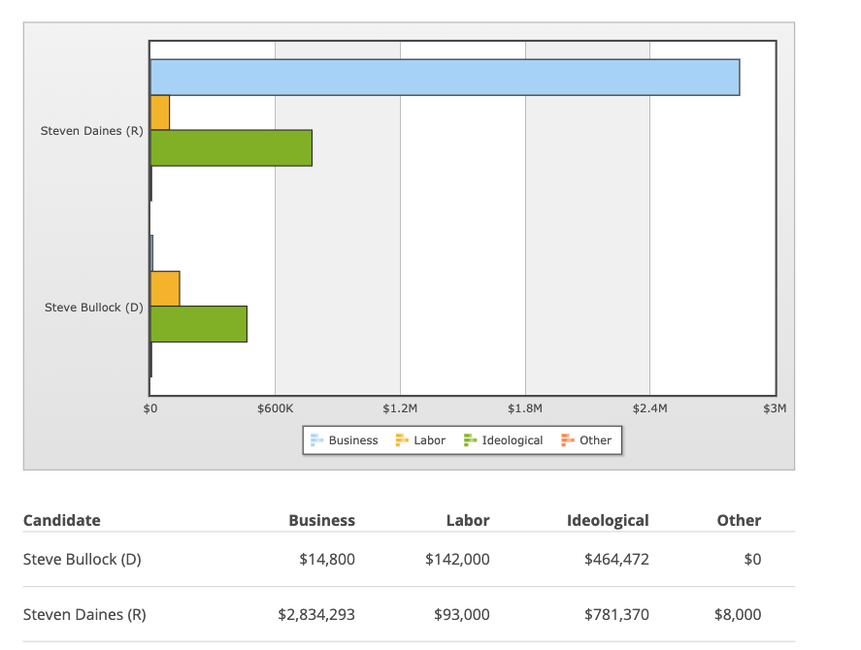

1. Statewide Elected Officials in Montana over the past two decades. Credit to Montana Free Press

# 

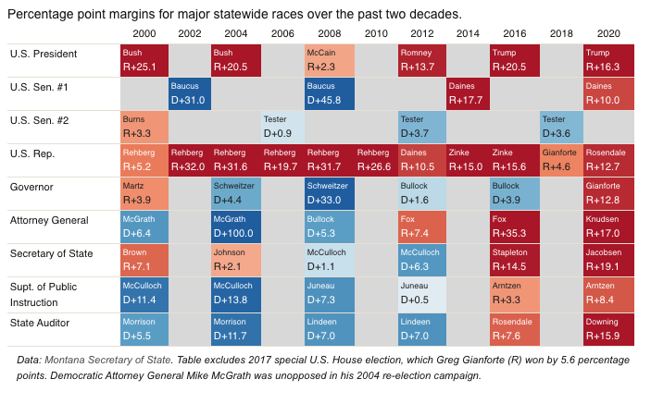

Works Cited:

* Mike Dennison, “What happened? Most pollsters greatly underestimated GOP vote in Montana,” *Missoula Current,* November 11, 2020, <https://missoulacurrent.com/government/2020/11/montana-polls/>
* Eric [Dietrich](https://montanafreepress.org/author/edietrich/) and [Mara Silvers](https://montanafreepress.org/author/mara-silvers/), “Politicos explain Montana’s red wave,” *Montana Free Press*, November 11, 2020, <https://montanafreepress.org/2020/11/11/politicos-explain-montanas-red-wave/>?
* Emerson College Polling, “Montana 2020: Republicans Hold Advantages in Presidential, US Senate and Governor Races,” October 5-7, <https://emersonpolling.reportablenews.com/pr/montana-2020-republicans-hold-advantages-in-presidential-us-senate-and-governor-races>
* Public Policy Polling, October 9-10, 2020, “Montana Survey Results,” <https://www.publicpolicypolling.com/wp-content/uploads/2020/10/MontanaOctober2020Poll.pdf>
* Montana State University Bozeman, “TREASURE STATE 2020 POLL RESULTS: THE MONTANA U.S. SENATE RACE,” October 11, 2020, <https://helpslab.montana.edu/documents/treasure_state_2020_election_surveys/Senate_Overview_Final_11Oct2020.pdf>
* Maritsa Georgiou, “NBC Montana/Strategies 360 poll shows extremely tight Montana races,” *NBC Montana,* October 22nd 2020, <https://nbcmontana.com/news/beyond-the-podium/nbc-montanastrategies-360-poll-shows-extremely-tight-montana-races>
* The New York Times/Siena College Research Institute, “758 Montana Likely Voters,” October 18-20, 2020, <https://int.nyt.com/data/documenttools/mt101820-crosstabs/1bf52689f78606b4/full.pdf>
* Open Secrets, “Montana Senate Race Outside Spending,” <https://www.opensecrets.org/races/outside-spending?cycle=2020&id=MTS2>
* Open Secrets, “Sen. Steven Daines - Montana,” <https://www.opensecrets.org/members-of-congress/steven-daines/elections?cid=N00033054&cycle=2020>
* Open Secrets, “Steve Bullock (D),” <https://www.opensecrets.org/2020-presidential-race/steve-bullock/candidate?id=N00044652>

# Maritsa Georgiou, “Montana Senate race among the most expensive in US,” *NBC Montana,* November 2nd 2020, <https://nbcmontana.com/news/local/montana-senate-race-among-the-most-expensive-in-us>

* Phil Drake, “Steve Daines reelected in U.S. Senate race in Montana”, *Great Falls Tribune,* <https://www.greatfallstribune.com/story/news/2020/11/04/montana-election-results-steve-daines-wins-us-senate-steve-bullock/6155102002/>

# Eric Dietrich, “Where is the unprecedented money flooding Montana’s Senate race coming from? Mostly out of state,” *Montana Free Press,* Nov 1, 2020, <https://billingsgazette.com/news/state-and-regional/where-is-the-unprecedented-money-flooding-montana-s-senate-race-coming-from-mostly-out-of/article_634e49a3-7dfa-5a5c-b6cf-ebcaddb61a4c.html>

* Anna Rau, “How Montana’s Senate Race became so competitive--and costly,” *PBS News Hour,* October 28, 2020, <https://www.pbs.org/newshour/show/how-montanas-senate-race-became-so-competitive-and-costly>
* Kate Ackley, “Bullock attacks money in politics as super PAC goes after Daines,” *Roll Call,* May 7, 2020, <https://www.rollcall.com/2020/05/07/bullock-attacks-money-in-politics-as-super-pac-goes-after-daines/>
* Matthew Brown, “Trump noticeably absent from key US Senate race in Montana,” *Associated Press,* November 1, 2020, <https://abcnews.go.com/Politics/wireStory/trump-noticeably-absent-key-us-senate-race-montana-73958019>
* “Montana Counties Benefit from Medicaid Expansion,” Montana Budget and Policy Center, October 17, 2018, <https://montanabudget.org/post/county-benefits-medicaid-expansion?fbclid=IwAR0aqNxFkuEcwUUjPcyGC5ylqflj1XrUv-H8DfoV6pozdaEvnQig6azYPF0>
* Matthew Brown, “Health care, high court battle dominate Montana Senate race,” *Associated Press*, September 28, 2020, <https://apnews.com/article/virus-outbreak-election-2020-steve-daines-missoula-montana-cfb581187ff0abe2efdd90db65b056b3>
* David Lim, “Daines holds Montana Senate seat for GOP,” *POLITICO,* November 4, 2020, <https://www.politico.com/news/2020/11/04/montana-senate-election-results-2020-433588>
* Chris Aadland, “Daines wins re-election to U.S. Senate,” *Montana Free Press*, November 11, 2020, <https://montanafreepress.org/2020/11/04/daines-wins-re-election-to-u-s-senate/>?
* Dena Bunis, “AARP Poll: Economy is Top Issue for MT Voters age 50+,” *AARP,* September 15, 2020, <https://states.aarp.org/montana/2020-election-poll>
* “United States Senate election in Montana, 2020,” *Ballotpedia*, <https://ballotpedia.org/United_States_Senate_election_in_Montana,_2020>
* [Jonathan Martin](https://www.nytimes.com/by/jonathan-martin), “*Steve Bullock Is Running for Senate in Montana,” NYT*, March 4, 2020, <https://www.nytimes.com/2020/03/04/us/politics/steve-bullock-montana-senate.html>
* Noah Kim, “Misleading ad in Montana Senate race casts Steve Daines as soft on drug companies,” *PolitiFact,*  August 25, 2020, <https://www.politifact.com/factchecks/2020/aug/25/duty-and-honor/misleading-ad-montana-senate-race-casts-steve-dain/>

Advertisements:

* <https://www.facebook.com/ads/library/?id=1610425279137951>
* <https://www.facebook.com/ads/library/?id=1489315087946381>
* <https://fb.watch/27-Eph_LZd/>